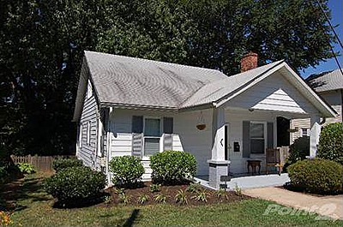

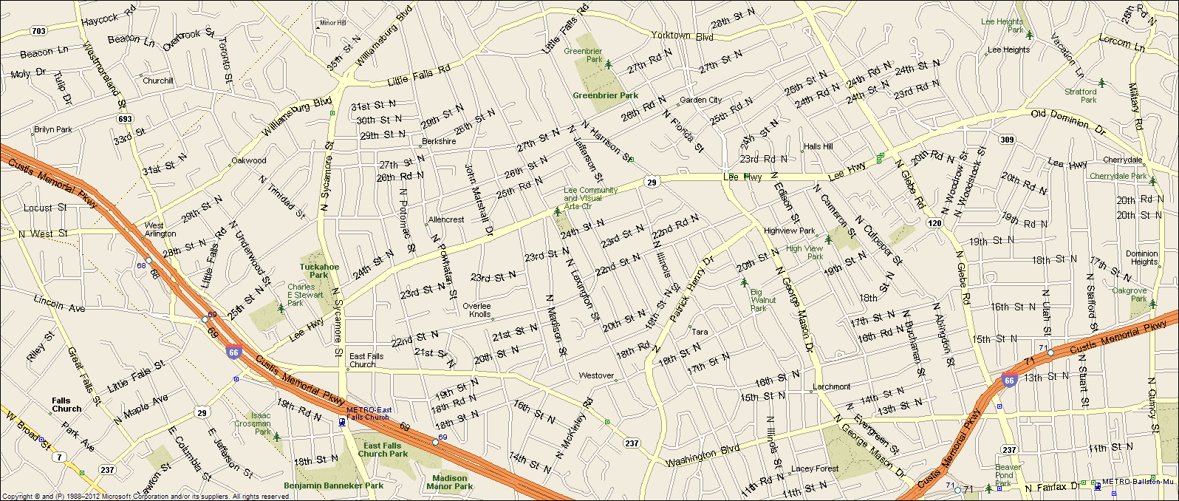2412 N Madison Street Arlington,VA 22205
Great location: Walk to EFC Metro & Westover Village & Library, District Taco, and the new Italian Deli, Close to DC (6 miles), Tyson’s Corner (6 miles), I-66, Rt. 29
- Four bedrooms, three full baths, on three levels.
- Updated kitchen w SS appliances
- Updated bathrooms on the main and top level.
- Central a/c, natural gas heat & hot water.
- Large landscaped yard, great back yard.
- Original hardwood floors thru out, recently refinished.
- Established quiet neighborhood.
- Excellent Schools: Tuckahoe Elementary, Swanson MS, & Yorktown HS
- Lease terms: 1 year minimum, no smoking, no use of fire place.

RENT: $3,600.00 / month + utilities, contact Lyndsay Saffer 703-906-3082
Email: safferlyndsay@gmail.com

